Algebra EOC Score Scale Score: ________________________ Level: __________________
Algebra/Geometry EOC Levels
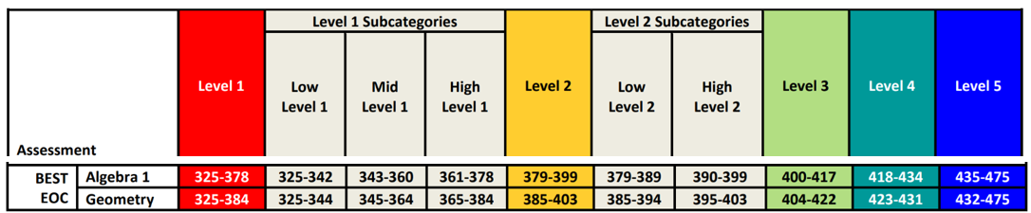
How close were you to the next level – how many points away? ___________________
How many points would you need to make a learning gain? ___________________
Expressions, Functions,  and Data Analysis | Linear Relationships | Non-Linear Relationships
Write if you were below, at/near, or above average in each category
Highlight each one below – pink at/near – yellow above – green
1st Quarter Grade | 2nd Quarter Grade | Midterm  Grade | Semester 1 Grade | 3rd Quarter  Grade | 4th Quarter  Grade | Final  Grade
Goal:  Act:  Abs: | Goal:  Act:  Abs: | Goal:  Act: | Goal:  Act:  GPA: | Goal:  Act:  Abs: | Goal:  Act:  Abs: | Goal:  EOC Grd:  FINAL:
Use link below to determine what your end of course grade could be!
https://rhsynwa.com/eoc-calculate-final-grade/

My 2027 Geometry EOC Goal Scale Score _____________ Goal level 3 4 5 (highlight)

ACTUAL SCALE ________ ACTUAL LEVEL______ HOW FAR? _____
List three specific steps you can take to accomplish each of your goals (EOC & Grades)!
1.

2.

3.

Benchmark Assessment Test (BAT)
P NP _______ Expressions and Equations (40%)
P NP _______ Geometry and Measurement (20%)
P NP _______ Fractions, Ratios/Proportional relationships and Statistics (40%)

