STANDARDS
*FROM RESULTS OF CCA’S
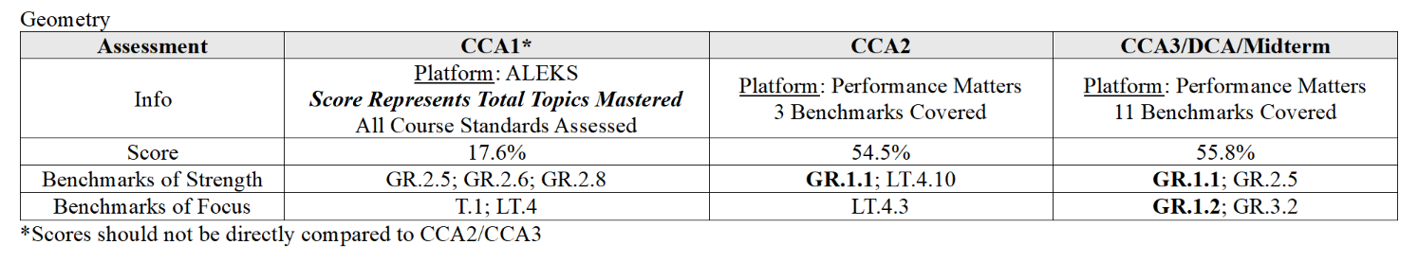
*FROM THE DISTRICT PUSH PLAN
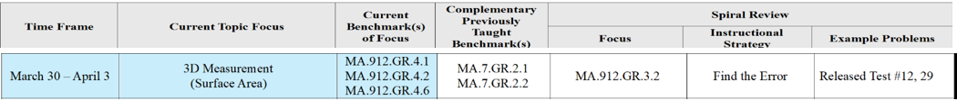

*I’ll be doing Center Activities with the students this week to review Standards from the CCA3 that should be Benchmarks of Focus GR3.2 (also a Focus from the District Push Plan).
The remainder of the Centers are from the District Push Plan this week based on Current Benchmarks (New Concepts) students will complete hands on activities to discover GR.4.1, 4.2, and 4.6.
Also including Spiral Review from the Push Plan as stated above GR 3.2 from the Released EOC test that students have been working on as well.

*Centers are carefully arranged by students who completed the Push Plan Progressive Plan Standards Packet we created from the problems on Schoology that the students entered their responses in the TInspires to get the instant results of which students I need to work with in small groups first.

The other groups are carefully arranged to make sure each group has a leader to assist in the new activities being introduced.

CENTER #1
*CCA3 Midterm Benchmark of Focus – Center (From the Midpoint Review)
MA.912.GR.3.2
Given a mathematical context, use coordinate geometry to classify or justify definitions, properties and theorems involving circles, triangles or quadrilaterals.
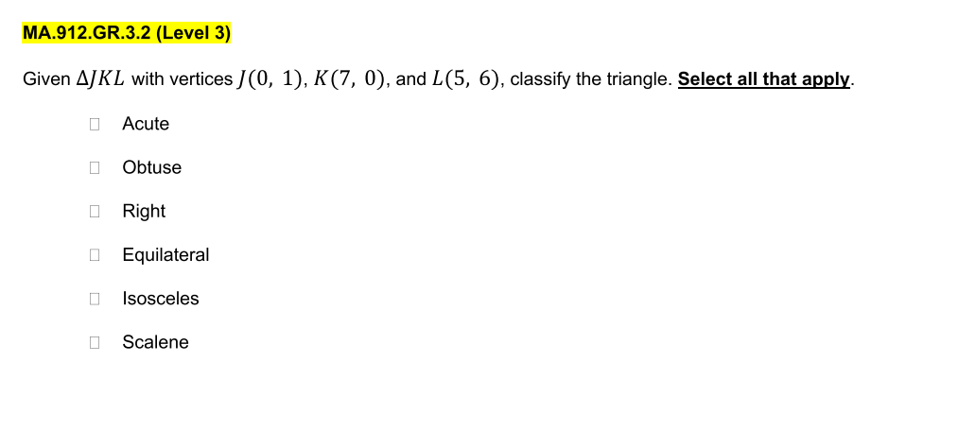
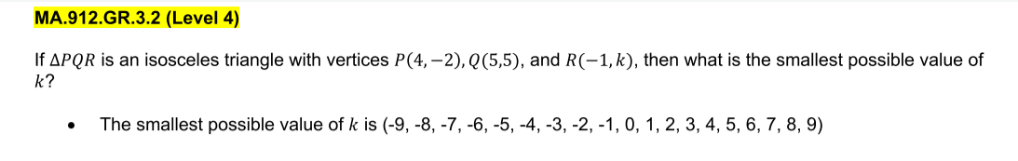
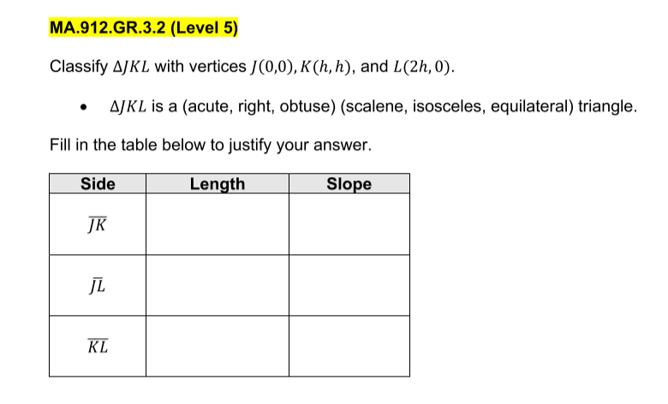

CENTER #2 -
*PUSH PLAN SPIRAL REVIEW – Center (From the Released EOC Problems) #12 & 29MA.912.GR.3.2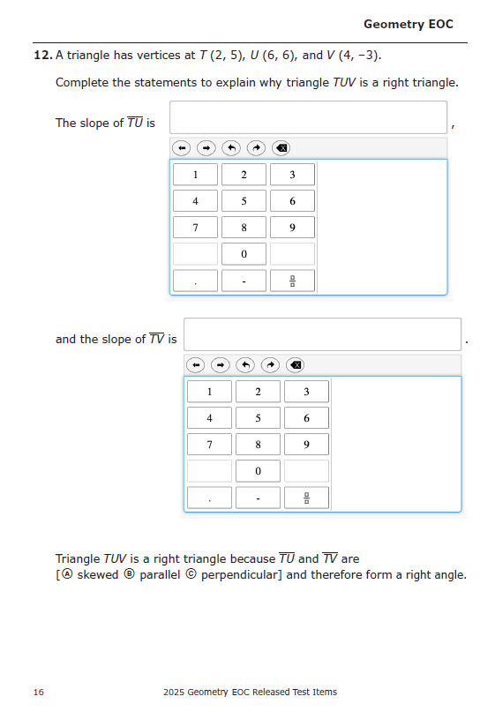

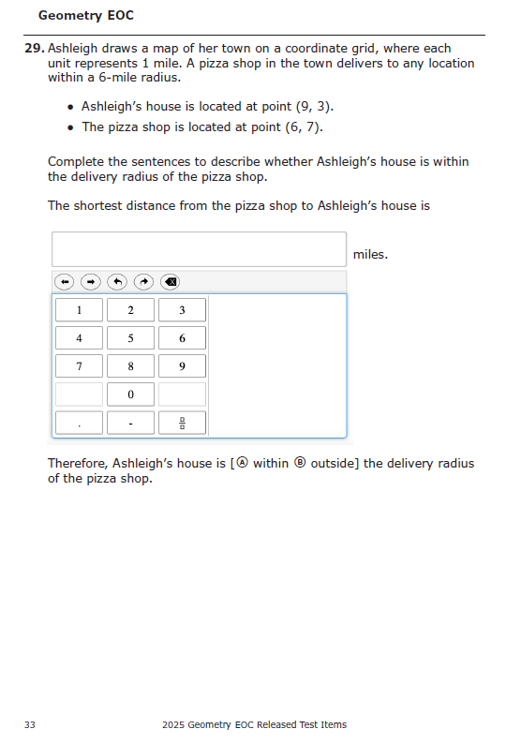

CENTER 3 –
New concept being introduced from PUSH PLAN– Hands on Activity to Prove Surface Area Formula and Solve for Surface Area for 3 Dimensional Figures.
MA.912.GR.4.6
Solve mathematical and real-world problems involving the surface area of three-dimensional figures limited to cylinders, pyramids, prisms, cones and spheres.

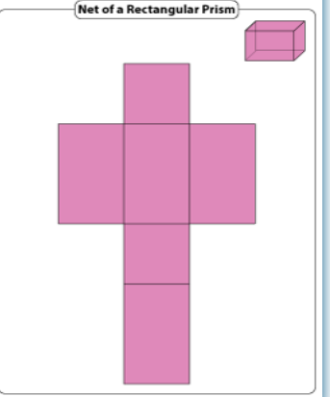
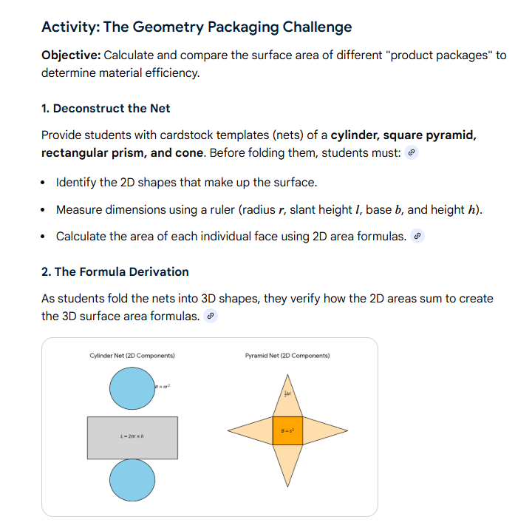

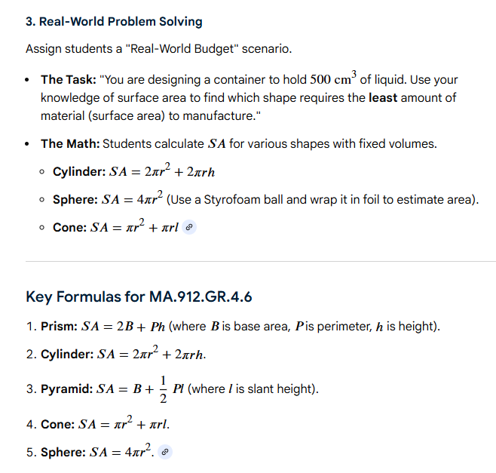

CENTER 4 –
New concept being introduced from PUSH PLAN- Geogebra Interactive Activities to visual new concepts.
MA.912.GR.4.1
Identify the shapes of two-dimensional cross-sections of three-dimensional figures
Geogebra Activity:
https://www.geogebra.org/m/mSuj7hqK#chapter/282332
*I have a worksheet activity that goes with this.

MA.912.GR.4.2
Identify three-dimensional objects generated by rotations of two-dimensional figures
Geogebra Activity:
https://www.geogebra.org/m/UMHXAvhb
*I have a worksheet activity that goes with this.
CENTER 5 –
Last week students worked on the “Progressive Problems” Push Plan Standards from Schoology Packet. They entered specific problems into the TI’s system in order for me to evaluate which students need the extra “small group” assistance.

*SMALL GROUP REVIEW of PUSH PLAN PACKET

