Name: Date:

Student Exploration: Isosceles and Equilateral Triangles

Activity A:  Exploring isosceles triangles | Get the Gizmo ready:  - Be sure Show bisector options is not selected. | 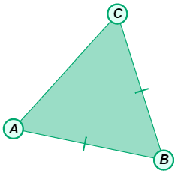

- Set the Condition selected is Two sides congruent to create an isosceles triangle.

  - The congruent sides of an isosceles triangle are called legs. The other side is called the base. Drag the vertices to change the triangle.

Which sides are the legs of ΔABC? Which is the base?

  - The two angles that are adjacent to the base are the base angles. Select Show angle measure tool to turn on the Gizmo protractors.

What are the measures of the base angles of ΔABC?

  - With both protractors still set on base angles, drag the vertices of the triangle to create different isosceles triangles. What do you notice about the base angles?

  - Complete the statement: If two sides of a triangle are , then

This is the called the Isosceles Triangle Theorem.

- Turn off both protractors and set Condition to Two angles congruent.

- Which two sides are opposite the congruent angles?

- Select Show ruler to turn on the Gizmo rulers. Then measure these sides. What do you notice about the lengths?

- Drag the vertices. Does your finding above seem to always be true?

- Use those observations to complete the following statement:

If two angles of a triangle are , then

The statement you wrote is the Converse of the Isosceles Triangle Theorem.

- Set Condition to None, and select Show bisector options. Then choose Show perpendicular bisector of $\overline{AC}$.

- Drag all three vertices to see many different triangles. Pay attention to when the perpendicular bisector passes through point B.

What type of triangle does this appear to be?

Set the triangle in the Gizmo to that type, and verify your finding.

- Use the Gizmo protractors on your triangle to measure ∠ABD and ∠CBD. Drag the vertices around. What do you notice?
- Complete: The perpendicular bisector of the base of a(n) triangle is also of the vertex angle.

- With Two sides congruent selected, choose Show bisector of ∠B.

- Why are the triangles that were formed congruent?

- What is true about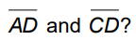 Verify this using the rulers.

- What type of angles are ∠ADB and ∠CDB? Verify this also.

- What do parts B and C prove about the angle bisector of the vertex angle of an isosceles triangle?

- Use what you have learned in Activity A to find the values of x and y. Show your work.
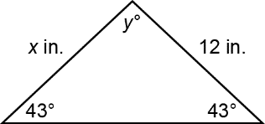
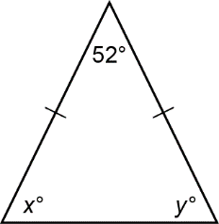
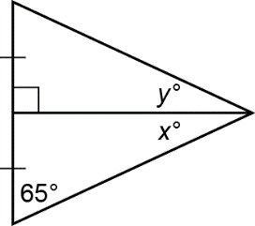

x =

y =

x =

y =

x =

y =

Activity B:  Exploring equilateral triangles | Get the Gizmo ready:  - Turn off the Gizmo rulers and unselect Show bisector options. | 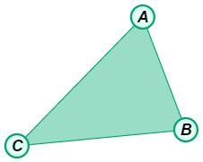

- In the Gizmo, set Condition as Three sides congruent to create an equilateral triangle.

  - First, are equilateral triangles also isosceles?

  - Use the Gizmo protractors to measure all three angles. What do you find?

  - Drag the vertices to create other triangles. What appears to be true for the angles of any equilateral triangle?

- Set Condition to Three angles congruent to create an equiangular triangle.

- Turn off the protractors and select the Gizmo rulers. Measure the three side lengths of the equiangular triangle. What do you find?

- Drag the vertices around. Does your finding appear to be true for any equiangular triangle?

- Explain the relationship between equilateral and equiangular triangles.

