Name: Date:

Student Exploration: Constructing Parallel and Perpendicular Lines

Activity A:  Constructing parallel lines | Get the Gizmo ready:  - Select Construct a parallel line. | 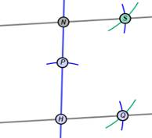

The Gizmo gives instructions for constructing a line parallel to a given line, through a point not on the given line. Follow the steps given in the Gizmo. After you complete each step, click Continue to go on to the next step.

At any time, if you wish to understand the overall strategy for this construction, click How? If you need help understanding the purpose of a particular step, click Why? If you want to start over on the construction, click Reset.

After you finish the Gizmo construction, click Reset and do the construction again. If possible, do the construction on a separate piece of paper using a compass and straightedge. Use the Gizmo as your guide to complete each step of the construction. Answer the following questions as you go along.
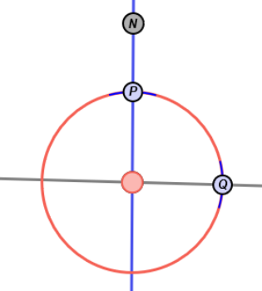
H
- At the beginning of step 4, points P and Q appear. What is the relationship of points P and Q to point H?

- In step 6, why is it important to keep the compass opening the same as it was in step 5?

- In step 8, which two lines are parallel?

- Which two angles did you construct to be congruent?

Select Show angle measure tool to open the Gizmo protractors. Attach the “donuts” to points on each angle to check that they are congruent.

- Why do these two congruent angles guarantee that the lines are parallel?

Activity B:  Constructing perpendicular lines | Get the Gizmo ready:  - Turn off the Gizmo protractors.  - Select Construct a perpendicular line. | 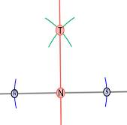

Follow the directions given in the Gizmo to construct a line perpendicular to line L that passes through point N. After you complete each step, click Continue to go on.

At any time, if you wish to understand the overall strategy for this construction, click How? If you need help understanding the purpose of a particular step, click Why? If you want to start over on the construction, click Reset.

After you finish the Gizmo construction, click Reset and do the construction again. If possible, do the construction on a separate piece of paper using a compass and straightedge. Use the Gizmo as your guide to complete each step of the construction. Answer the following questions as you go along.
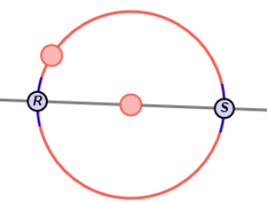
N
- At the beginning of step 2, points R and S appear in the diagram. hat is the relationship of points R and S to point N?

- In step 2, place the compass point at R and make the radius very small. Click Continue.

- What feedback does the Gizmo give you?

- Why should the radius be greater than the distance between points R and N?

- In step 5, which lines are perpendicular? Use the Gizmo protractor to verify.

- Select Show ruler to open the Gizmo rulers. Attach the “donuts” of one ruler to points R and T, and the donuts of the other ruler to points S and T.

- What is the relationship between 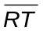 and 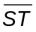?

- How does this relationship guarantee that the lines you constructed are perpendicular?

