Name: Date:

Student Exploration: Triangle Inequalities

Vocabulary: equilateral, inequality, isosceles

Gizmo Warm-up
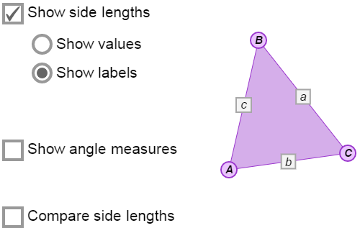
In the Triangle Inequalities Gizmo, you will explore how the measures of the sides and angles of a triangle are related. You will use the Gizmo to discover important inequalities that apply to triangles. An inequality is a relationship in which one quantity is greater than or less than another quantity.

To begin, explore how the vertices and sides of a triangle are labeled. Be sure Show side lengths and Show labels are turned on.

- Fill in the blanks below with the lowercase label that corresponds to each side.

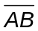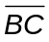

- How are these lowercase labels related to the vertices of the triangle?

- Vary the triangle by dragging its vertices around. How do you think a + b compares to c?

Activity A:  Side inequalities | Get the Gizmo ready:  - Be sure Show side lengths and Show labels are selected. | 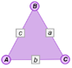

- In the Gizmo, drag the vertices to make a triangle with sides that are all about equal lengths.

- Imagine that your triangle is a map. Do you think c or a + b is the shortest route from point A to B? Select Compare side lengths and c and a + b to check.
- Write an inequality to describe how c is related to a + b.

- Watch the values under Compare side lengths as you create a variety of triangles. Is the inequality you wrote above true for all the triangles you created?

- In the Gizmo, create a situation in which c is equal to a + b.

- What do you notice?

- Is the figure you created still a triangle?

- In the Gizmo, be sure Compare side lengths is still selected.

- Select a and b + c under Compare side lengths. Create a variety of triangles. Write an inequality to describe the relationship between a and b + c.
- Select b and a + c under Compare side lengths. Create a variety of triangles. Write an inequality to describe the relationship between b and a + c.
- How does the sum of two side lengths of a triangle compare to the third side length?

This relationship is known as the Triangle Inequality Theorem.

- Determine if each of the following can be side lengths of a triangle. If not, explain why not.

- 2, 6, 11

- 8, 8, 15

- 13, 16, 29

Activity B:  Angle inequalities | Get the Gizmo ready:  - Turn off Compare side lengths.  - Turn on Show side lengths and Show values.  - Select Show angle measures. | 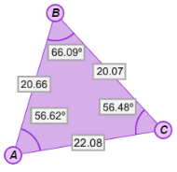

- In the Gizmo, drag the vertices to create a triangle with three different angle measures.

- List the angles in order from smallest to largest.

- Look at the sides opposite each angle. Write the names of the sides in order from shortest to longest.
- Compare the order of the sides and the angles. What do you notice?

Create a variety of triangles to check that this is always true.

- An isosceles triangle has at least two congruent sides. What do you think is true about the angles of an isosceles triangle?
Check your answer in the Gizmo.

- An equilateral triangle has three congruent sides. What do you think is true about the angles of an equilateral triangle?
Check your answer in the Gizmo.

- Summarize what you have learned in this activity by completing the statements below.

- In any triangle, the longest side is opposite the angle and the shortest side is opposite the angle.

- In any triangle, the largest angle is opposite the side and the smallest angle is opposite the side.

Activity C:  Using triangle inequalities | Get the Gizmo ready:  - Turn off Compare side lengths.  - Turn on Show side lengths and Show values.  - Select Show angle measures. | 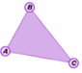

Recall that the following inequalities are true for all triangles:
- The sum of two side lengths is greater than the third side length. (This is the Triangle Inequality Theorem.)
- The longest side is opposite the largest angle and the shortest side is opposite the smallest angle.
- The largest angle is opposite the longest side and the smallest angle is opposite the shortest side.

Use these relationships to solve the problems below.

- In ΔABC, m∠A = 53°, m∠B = 69°, and m∠C = 58°. Name the longest and shortest sides.

Longest side: Shortest side: Check your answers in the Gizmo.

- The lengths of two sides of a triangle are 3 feet and 9 feet. Find the range for the length of the third side. Explain your reasoning.

