Name(s): Date:

Student Exploration: Investigating Angle Theorems

Vocabulary: complementary angles, linear pair, supplementary angles, vertical angles

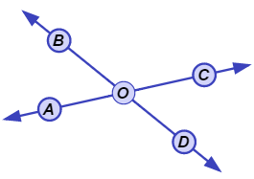
Gizmo Warm-up
In the Investigating Angle Theorems Gizmo, you can manipulate a dynamic figure to explore the properties of different angles.

- In the Gizmo, select Vertical angles from the Conditions menu. You should see two intersecting lines like the ones shown to the right.

- Name the two pairs of angles that do not share a side. (They are nonadjacent.)
and and Both pairs are vertical angles.
- Drag the points to resize the angles. What appears to always be true about the measures of the vertical angles?
Turn on Show angle measures and continue to resize to check if this is always true.

- Select Form a linear pair to view a linear pair of angles (adjacent angles whose non-common sides form a straight line).

- Name the linear pair by naming the adjacent angles.

- Adjust the angles by dragging point B. What seems to always be true about the measures of a linear pair of angles?
Turn on Show angle measures. Drag point B to check if this is always the case.

Activity A:  Complements and supplements | Get the Gizmo ready:  - Under Conditions, select Complementary to congruent angles.  - Be sure Adjacent is selected. | 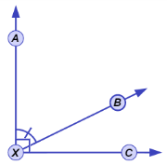

- Both pairs of angles shown (∠AXB and ∠BXC, and ∠DYE and ∠EYF) are complementary.

  - Drag points B and E to view a variety of complementary angles. What is true about the measures of two complementary angles?
  - What must be true about ∠AXB and ∠DYE?

Turn on Show angle measures and drag point B to verify for a variety of angles.

  - Select Nonadjacent and drag the points. Which two angle pairs are complementary?

and and

  - What must be true about ∠CXD and ∠GZH?

Turn on Show angle measures. Experiment to see if this is always true.

  - What is true of any pair of angles that are complementary to congruent angles?

- Select Complementary to same angle and drag points A, B, C, and D.

- What are the two pairs of complementary angles in this figure?

and and

- What must be true about ∠AOC and ∠DOB?

Turn on Show angle measures and drag the points to verify this.

- Select Nonadjacent and run a similar test. What is true about angles that are complementary to the same angle?

- Select Supplementary to congruent angles. Both angle pairs shown (∠AXB and ∠BXC, and ∠DYE and ∠EYF) are supplementary and form linear pairs.

  - Drag points B and E to view a variety of supplementary angles. What can you say about the measures of two supplementary angles?
  - What must be true about ∠AXB and ∠DYE?

  - Select Nonadjacent and run a similar test. What is true about angles that are supplementary to congruent angles?

- Select Supplementary to same angle. Drag the points to view a variety of figures.

- Name two pairs of supplementary angles that contain ∠BOC.

and and

- What must be true about ∠AOB and ∠COD?
Turn on Show angle measures and create a variety of figures to verify this.

- Select Nonadjacent and run a similar test. What is true about angles that are supplementary to the same angle?

- Select Vertical angles and turn on Show angle measures. Drag point A until ∠AOB is a right angle.

What is true about the four angles formed? Experiment to see if this is always true.

Activity B:  Using angle concepts | Get the Gizmo ready:  - Select Supplementary and congruent under Conditions. | 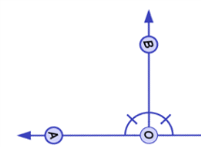

- Drag the points to see several pairs of angles that are supplementary and congruent.

What is true about the measures of angles that are supplementary and congruent?

Turn on Show angle measures to check. Then, select Nonadjacent to check that this also applies to nonadjacent angles.

- Solve each problem. Show all of your work. Then, if possible, check in the Gizmo.

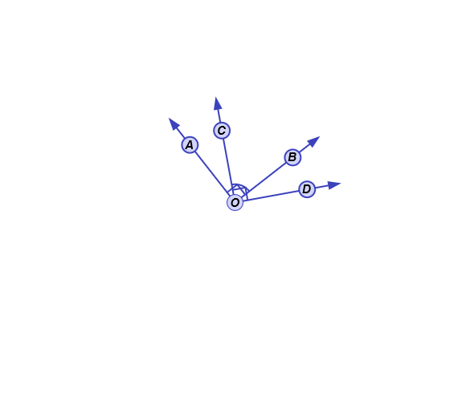
62°
- Find the measures ∠AOC and ∠DOB.

50°
(4x + 10)°
2y°

- Find the values of x and y

