Name: Date:

Student Exploration: Distance Formula

Activity A:  Distance between two points | Get the Gizmo ready:  - Be sure Show values is turned on. | 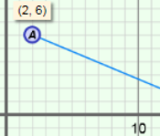

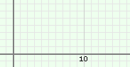
- Drag point A to (2, 6) and point B to (14, 1).

- Sketch the points and the segment between them on the grid to the right. Sketch segments to represent the horizontal and vertical distances between the points. Connect these segments to a third point C.

What type of figure did you draw?

- For the figure you drew above, label the long leg a, the short leg b, and the hypotenuse c. (The labels a, b, and c represent the lengths of the sides.)

What are a and b, the lengths of the legs? a = b =

- Use the Pythagorean Theorem (a² + b² = c²) to find c, the length of the hypotenuse of the right triangle. Show your work in the space to the right. Use the Gizmo ruler to check your calculation.

- Suppose the coordinates of point A are (x₁, y₁) and the coordinates of point B are (x₂, y₂).

- Fill in the blanks below to show how you can use these coordinates to find a and b.

a = b =

Turn on Show triangle and select Show labels to check your answers.

- The Pythagorean Theorem can also be written c² = a² + b². Substitute the values you found for a and b above into this equation to write an expression for c² in terms of x₁, y₁, x₂, and y₂.

c² =

- Substitute d (distance) for c (length of hypotenuse). Then solve for d by taking the square root of both sides.

d =

This is called the distance formula. Select Show distance computation to check your formula. Make corrections if necessary.

(Activity A continued on next page)
Activity A (continued from previous page)
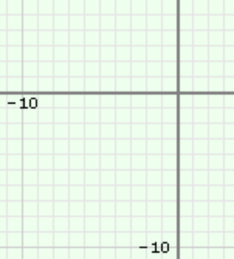
- Select Show values and turn off everything else.

- Drag point A to (–6, –5) and point B to (–1, 4). On the grid to the right, make a labeled sketch of the triangle that can be used to find the distance between the points.

- Use the distance formula, d = 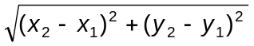, to find AB. Round to the nearest hundredth if necessary. Show your work in the space below.

- Turn on Show distance computation to check your work above. Why is it not necessary to use the absolute value of the differences of the coordinates in the distance formula?

- Switch the order in which you subtract both coordinates in the distance formula. Do you get the same distance? Why or why not?

- Use the distance formula to find the distance between each pair of points. Round to the nearest hundredth if necessary. Write all your steps in the space below each problem. When possible, check your answers in the Gizmo. (The last one cannot be modeled in the Gizmo.)

- (–7, 9) and (3, –5)

B. (12, –8) and (–4, 1)

Activity B:  Using the distance formula | Get the Gizmo ready:  - Turn off everything except Show values. | 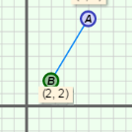

O
North
Lana
Tim
- Lana and Tim live in a part of town where the streets form a grid. The general location of their houses is shown on the grid to the right. Each unit on the grid represents one mile.

- Tim drives directly south, and then directly west to get to Lana’s house. Sketch this path on the grid to the right. How many miles in each direction does he drive?

- What are the coordinates of each house? Tim: Lana:

- A crow flies along a straight line from Lana’s house to Tim’s house. Sketch a path on the grid above to show the crow’s path. Then plot the points in the Gizmo (use point A for Tim and point B for Lana). Select Show triangle to check your work.

What type of figure do all three paths make?

- Use the Pythagorean Theorem to find the distance the crow flies to the nearest hundredth. Show your work.

- Use the distance formula to find the distance the crow flies to the nearest hundredth. Show your work. Check your answer in the Gizmo.

- Which method do you find easier? Why?

