Name: Date:

Student Exploration: Similarity in Right Triangles

Activity A:  Similar right triangles | Get the Gizmo ready:  - Turn off Show side lengths. | 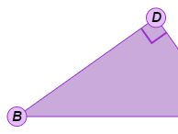

- In the Gizmo, click Animate, and then click Flip to get the triangles oriented the same.

- In the table below, list the three pairs of triangles that appear to be similar. Then list the three pairs of corresponding angles for each. Name each angle with three letters.

Pair of similar triangles | Corresponding pairs of angles

- What is true about the corresponding angles in similar triangles? Drag the vertices to create a variety of triangles. Use the Gizmo protractors to check if this true for the triangles you create.
- You can prove that each pair of triangles is similar without measuring angles. For each pair of triangles shown below, list two pairs of corresponding angles that you know are congruent without measuring. Then state a reason for each congruent pair.

Triangles | Congruent pair of angles | Reason
ΔABC and ΔDAC
ΔABC and ΔDBA

- Why do you now know that ΔABC ∼ ΔDAC and ΔABC ∼ ΔDBA?

- How does that prove that ΔDAC ∼ ΔDBA?

- In the Gizmo, be sure Δ1, Δ2, and Δ3 are all shown. (If you do not see all three triangles, click Animate and then Flip.) Turn off the Gizmo protractors.

- Name the three pairs of corresponding sides in each pair of triangles listed below.

Δ1 and Δ2:

Δ1 and Δ3:

Δ2 and Δ3:

Click on Show side lengths and select Labels to check your answers.

- Because the three triangles are similar, what is true about the lengths of each pair of corresponding sides?
- Under Show side lengths, select Values. Find the ratio of each pair of corresponding side lengths. Round this ratio to the nearest hundredth.

- In each triangle below, 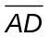 is the altitude to the hypotenuse of right ΔABC. Use similar triangles to find x to the nearest tenth. Show your work. (Note: Triangles are not to scale.)
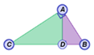
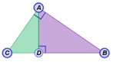
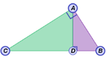
34
30
16
x
20
12
16
x
8
10
x

Activity B:  Geometric mean | Get the Gizmo ready:  - Be sure Show side lengths is turned off.  - If Δ1, Δ2, and Δ3 are all shown, click Animate so only Δ1 appears. | 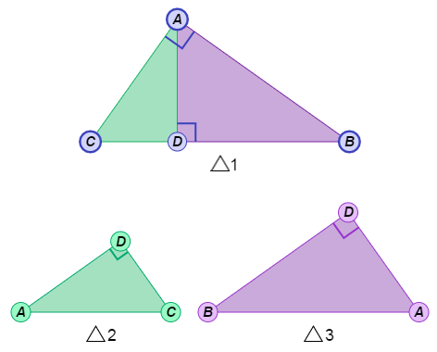

- Consider the numbers 5 and 45.

- What number would you have to multiply by 5 to get 45?

- If you wanted to start with 5 and end up with 45 by multiplying by the same number twice, what number would you use?
- Write the sequence of three numbers you would get by doing that: 5, , 45

The middle number you got above is the geometric mean of 5 and 45.

- What does the geometric mean squared equal? What is 5 • 45?

- Write two fractions to the right:
- 5 over the geometric mean, and
- the geometric mean over 45.

- Are the fractions equal? If so, they form a proportion. In general, in a proportion of the form  = 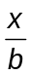, x is the geometric mean of a and b.

- In a right triangle, the altitude to the hypotenuse divides the hypotenuse into two segments. The length of a leg is the geometric mean of the lengths of the adjacent hypotenuse segment and the whole hypotenuse.

- Look at the large triangle (ΔABC) in the Gizmo. Write a proportion using CD, AC, and BC to illustrate this theorem. (Hint: Because the length of a leg is the geometric mean, that length appears twice in this proportion.)
=

- In the Gizmo, click on Animate and then Flip. Which two similar triangles allow you to form this proportion? Δ and Δ
- Which length is the geometric mean of the other two lengths?

- Use the lengths of the other leg of ΔABC and its adjacent hypotenuse segment to write a proportion similar to the one you wrote above.
=

- Drag the vertices of Δ1 (ΔABC). Click Show side lengths and select Values.

- Sketch ΔABC in the space to the right. Label the legs, hypotenuse, and altitude with their lengths.

- Use proportions to find CD and BD for the triangle you sketched above. Show your work in the space to the right.

- In a right triangle, the length of the altitude to the hypotenuse is the geometric mean of the lengths of the segments of the hypotenuse formed by the altitude.

- In the Gizmo, drag the vertices to form a different right triangle. Under Show side lengths, select Labels. Write a proportion using AD, BD, and CD to illustrate this theorem.
=

- Which two similar triangles allow you to form this proportion? Δ and Δ

- Under Show side lengths, select Values. Sketch Δ1 in the space to the right. Label the legs, hypotenuse, and altitude with their lengths.

- Use proportions to find AD for the triangle you sketched above. Show your work in the space to the right.

- In each triangle below, is the altitude to the hypotenuse of right ΔABC. Use similar triangles to find x to the nearest tenth. Show your work. (Note: Triangles are not to scale.)

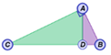
16
4
x

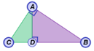
32
40
x

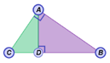
9
14.5
x

